Elementary rules of differentiation
Unless otherwise stated, all functions will be functions from R to R, although more generally, the formulae below make sense wherever they are well defined.

Differentiation is linear
Main article: Linearity of differentiation
For any functions f and g and any real numbers a and b.
In other words, the derivative of the function h(x) = a f(x) + b g(x) with respect to x is
In Leibniz's notation this is written
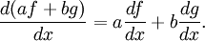
Special cases include:
- The constant multiple rule
- The sum rule
- The subtraction rule

The product or Leibniz rule
Main article: Product rule
For any of the functions f and g,
In other words, the derivative of the function h(x) = f(x) * g(x) with respect to x is
In Leibniz's notation this is written
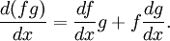

The chain rule
Main article: Chain rule
This is a rule for computing the derivative of a function of a function, i.e., of the composite of two functions f and g:
In other words, the derivative of the function h(x) = f(g(x)) with respect to x is
In Leibniz's notation this is written (suggestively) as:
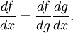

The polynomial or elementary power rule
Main article: Calculus with polynomials
If f(x) = x^{n}, for some natural number n (including zero) then
Special cases include:
- Constant rule: if f is the constant function f(x) = c, for any number c, then for all x
- The derivative of a linear function is constant: if f(x) = ax (or more generally, in view of the constant rule, if f(x)=ax+b ), then
Combining this rule with the linearity of the derivative permits the computation of the derivative of any polynomial.

The reciprocal rule
Main article: Reciprocal rule
For any (nonvanishing) function f, the derivative of the function 1/f (equal at x to 1/f(x)) is
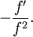
In other words, the derivative of h(x) = 1/f(x) is
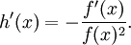
In Leibniz's notation, this is written
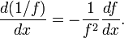

The inverse function rule
Main article: inverse functions and differentiation
This should not be confused with the reciprocal rule: the reciprocal 1/x of a nonzero real number x is its inverse with respect to multiplication, whereas the inverse of a function is its inverse with respect to function composition.
If the function f has an inverse g = f⁻¹ (so that g(f(x)) = x and f(g(y)) = y) then
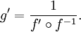
In Leibniz notation, this is written (suggestively) as
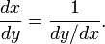

Further rules of differentiation

The quotient rule
Main article: Quotient rule
If f and g are functions, then:
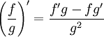wherever g is nonzero.
This can be derived from reciprocal rule and the product rule. Conversely (using the constant rule) the reciprocal rule is the special case f(x) = 1.

Generalized power rule
Main article: Power rules
The elementary power rule generalizes considerably. First, if x is positive, it holds when n is any real number. The reciprocal rule is then the special case n = -1 (although care must then be taken to avoid confusion with the inverse rule).
The most general power rule is the functional power rule: for any functions f and g,
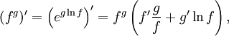
wherever both sides are well defined.

Logarithmic derivatives
The logarithmic derivative is another way of stating the rule for differentiating the logarithm of a function (using the chain rule):
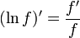wherever f is positive.

Derivatives of exponential and logarithmic functions
note that the equation above is true for all c, but the derivative for c < 0 yields a complex number.
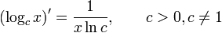
the equation above is also true for all c but yields a complex number.
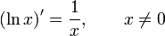
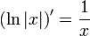
The derivative of the natural logarithm with a generalised functional argument f(x) is
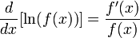
By applying the change-of-base rule, the derivative for other bases is
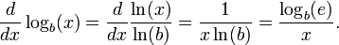

Derivatives of trigonometric functions
For more details on this topic, see Differentiation of trigonometric functions.
 | 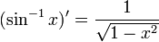
 | 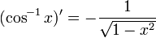
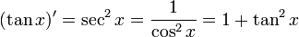 | 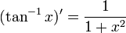
 | 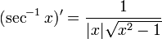
 | 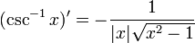
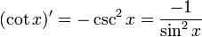 | 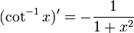

Derivatives of hyperbolic functions
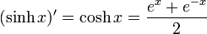 | 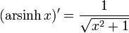
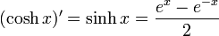 | 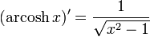
 | 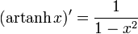
 | 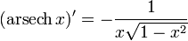
 | 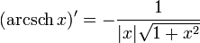
 | 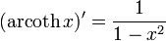

Derivatives of special functions
Gamma function
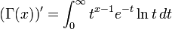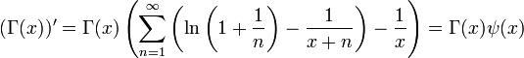

Riemann Zeta function
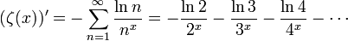
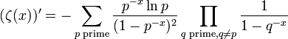

Nth Derivatives
The following formulae can be obtained empirically by repeated differentiation and taking notice of patterns; either by hand or computed by a CAS (Computer Algebra System).^{[1]} Below y is the dependent variable, x is the independent variable, real number constants are A, B, N, r, real integers are n and j, F(x) is a continuously differentiable function (the n^{th} derivative exists), and i is the imaginary unit .
Function | n^{th} Derivative
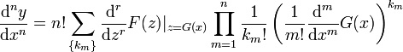
where 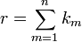
and the set consists of all non-negative integer solutions of the Diophantine equation 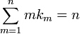
See: Expansions for nearly Gaussian distributions by S. Blinnikov and R. Moessner ^{[2]}
 | 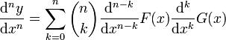
 | 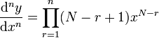
 | 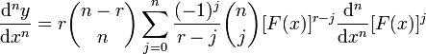
 | 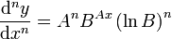
For the case of (the exponential function),  the above reduces to: | 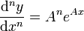
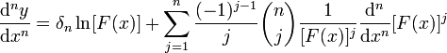
where 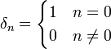is the Kronecker delta.
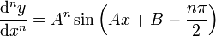
Expanding this by the sine addition formula yields a more clear form to use:
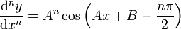
Expanding by the cosine addition formula:
 | 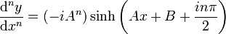
 | 